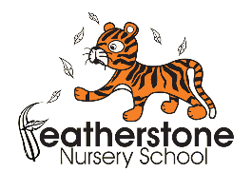*Federation of Osborne and Featherstone Nursery Schools*

**PACKED LUNCH POLICY**

**September 2025**

**Policy Statement**

At Federation of Osborne and Featherstone Nursery Schools, we are committed to promoting healthy eating and ensuring food safety in accordance with:

* [Early Years Foundation Stage (EYFS) statutory framework](https://www.gov.uk/government/publications/early-years-foundation-stage-framework--2)
* [Health and Safety regulations including food hygiene regulations and safe storage practices](https://www.food.gov.uk/)
* Support with achieving the Government’s Public Health Service ambition for children to have a healthy weight for height range and be well nourished
* The DFE’s Help for Early Years
* The NHS Children's food: safety and hygiene

We aim to support children's health, development, and well-being by encouraging balanced, nutritious meals and maintaining a safe and inclusive environment for all dietary needs.

**Rights Respecting School**

This policy is in accordance with the 1989 United Nations Convention on the Rights of the Child (UNCRC)

* Article 3 - The best interests of the child must be a top priority in all things that affect children.

**Aims**

This policy is in place to:

* Provide guidelines for parent/carers on the expectations for packed lunches brought from home
* Ensure packed lunches brought from home provides children with healthy, balanced

and nutritious food, which meets their needs to be physically active, to learn, grow well, and be healthy.

* Comply with food hygiene and safety regulations.
* Meet EYFS requirements for nutrition, independence and self-care.
* Protect children with allergies and dietary needs.

**Packed Lunch Guidelines**

Drinks, such as water and milk, will be available for your child during the day. You will not need to provide your child with a drink.

Your child has a small stomach so make sure that portion sizes are the right size for your child.

Make sure that food provided is in manageable pieces and is not a choking hazard for your child. (See guidance in appendix 2)

A healthier packed lunch contains a portion of one of the four main food groups (see appendix 1 for healthy packed lunch ideas):

* **One or two portions of starchy foods:** Provide variety across the week and at least one wholegrain starchy food each week. This includes bread, wrap, chapatti, bagels, pasta, rice, noodles, couscous or potatoes. This should form part of the main meal and can be part of the dessert
* **At least one portion of vegetables and/or one portion of fruit:** Provide a variety of different vegetables and fruit each week. This includes carrot, cucumber, celery stick, chopped tomato and fresh, tinned, frozen, dried fruit such as sliced apple, chopped grapes, raisins (but remember, dried fruit is not suitable as a snack). Aim for your child to have 5 different vegetables and fruit across the day
* **One portion of beans, pulses, fish, eggs, meat and other proteins:** Provide a variety of different foods each week. This includes kidney beans, chickpeas (hummus), lentils (dahl), tofu, quorn, egg, sliced meat or poultry in sandwiches
* **One portion of dairy or an unsweetened calcium enriched alternative:** This includes cheese in a sandwich, unsweetened yoghurt or fromage frais, rice or semolina pudding

**Items to avoid:**

Parents/Carers are to avoid:

✖ Sugary foods (chocolate and sweets, such as chocolate buttons, chocolate biscuit, cereal bar, processed dried fruit product, fruit tinned in syrup, sweetened yoghurts and fromage frais).

✖ Foods labelled as ‘high’ (red) for sugar, salt or saturated fat

✖ Crisps and processed snacks high in salt or fat like savoury pastries. (Snack items such as crisps, puffs, pulse or grain-based crisps, coated or flavoured dried vegetables).

✖ Sugary drinks (fizzy drinks, squash, energy drinks).

✖ Nuts or nut-based products (strictly prohibited due to allergies).

✖ Artificial sweeteners as they encourage children to prefer very sweet foods

**Safe Storage & Handling of Packed Lunches**

To ensure compliance with food safety:

* All packed lunches must be provided in a clearly labelled, insulated lunchbox.
* Parents/Carers are advised to/required to bring packed lunches in suitable lunch boxes which must include ice packs to keep perishable food fresh.
* Refrigeration is not available therefore parents/carers should pack food that remains safe at room temperature. We will provide a storage area for packed lunch bags.
* We are unable to heat/ re-heat food for food hygiene purposes. Children cannot bring hot food in a thermos flask or container.
* Staff will monitor lunches for compliance with food safety and healthy eating standards.
* Any unsafe or unsuitable food will be returned home, and parents/carers will be informed.
* Children are only allowed to eat their OWN food
* We will ensure that even though children have brought in a packed lunch they will eat with their peers

**Waste and Disposal**

Staff will, within reason, send any uneaten packed lunch food items back home. This is so that parents/carers can also monitor what their child has consumed during the day and then raise any concerns over their child’s food intake with the nursery.

**Parental Notification (Food Allergies)**

* Parents/Carers must notify the setting in writing of any food allergies, intolerances, or dietary requirements. We recognise that some children may require a special diet. In this case parents/carers should notify the setting.
* Packed lunches should be handed directly to a staff member at drop-off to ensure compliance with our policy.
* Staff may inspect lunchboxes to ensure adherence to food safety and allergy guidelines

**Allergy & Food Safety Policy Compliance**

* We operate a strict NO-NUT policy—any nut-based products will be removed and returned to parents.
* All food must be safely prepared and stored at home following food hygiene guidelines.
* Parents/Carers must ensure food is fresh and appropriate for their child's dietary needs.
* Any concerns about a child's diet or food safety will be discussed with parents/carers.

**Non-Compliance & Right to Refuse Packed Lunches - to safeguard all children**

Parents/Carers must adhere to our allergy, food hygiene and healthy eating guidelines.

If a lunch does not meet our standards, we reserve the right to:

* Provide a suitable meal at an additional cost to parents/carers at a cost of £2.40
* Refuse packed lunches until compliance is ensured.
* Report ongoing non-compliance as a safeguarding concern, in line with EYFS regulations.

If a child comes without a packed lunch, we will call families to bring one in or charge if we have to provide lunch at a cost of £2.40

**Support for Parent/Carers**

If you need support in providing a healthy packed lunch, we are happy to offer guidance and resources. Please speak to a member of staff if you require any assistance.

You can also access guidance and ideas by visiting the following websites:

<https://www.firststepsnutrition.org/eating-well-early-years> <https://healthforunder5s.co.uk/sections/preschool/preparing-the-perfect-packed-lunch/>

**Links to other policies**

For further information on the food that is served at our nurseries, see our Federation Food and Nutrition Policy.

**Monitoring and Review**

The policy is regularly monitored by the Head Teacher to ensure that it is working as effectively as possible.

This policy will be reviewed annually or as necessary to ensure that it remains in line with EYFS, Ofsted, and food hygiene requirements and guidance.

Parents/Carers will receive a copy of this policy and reminders as needed.

Last reviewed: September 2025

Next review due: September 2026

**Parental Declaration**

I, __________________________________________________ (parent/carer name) confirm that:

✔ I understand and agree to follow the above Packed Lunch Policy

✔ I will not include any nut-based products or high-risk foods in my child’s packed lunch.

✔ I will ensure all food is safe, fresh, and appropriate for my child.

✔ I acknowledge that if I do not comply with this policy, the setting may refuse the packed lunch and provide an alternative meal at an additional charge.

Parent/Carer Signature: __________________________ Date: ___________________

Child’s Name:_________________________________________

Appendix 1

**Examples of healthy lunchboxes for nursery aged children**

Taken from Eating Well: Packed lunches for 1 to under-5 year olds (First Steps Nutrition Trust) 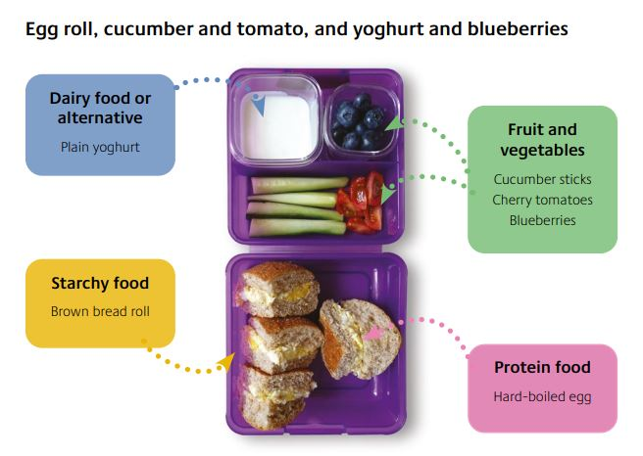

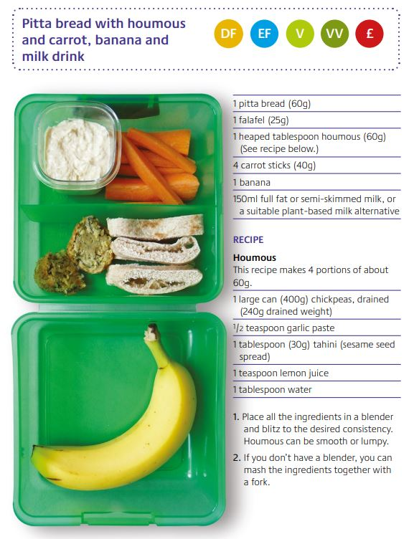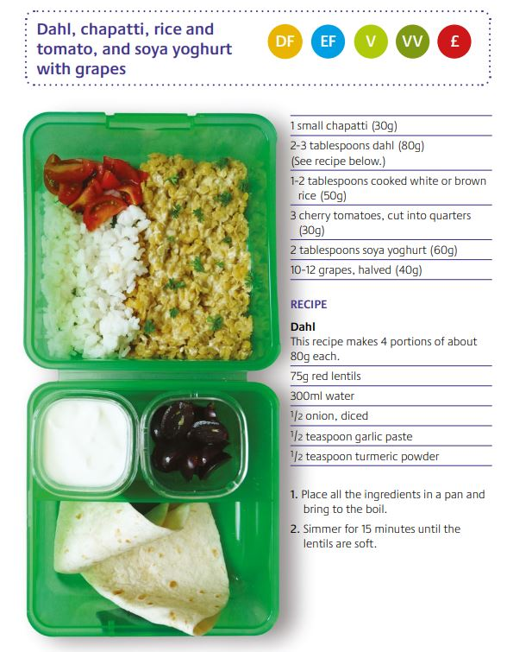



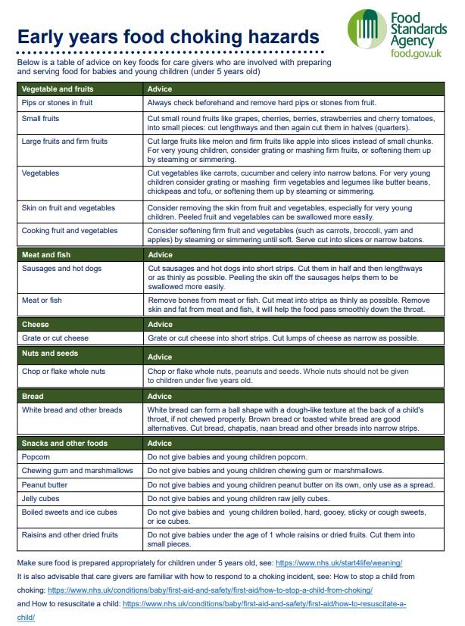Appendix 2